**JAM Electronics inc. (JE)**

**Group #36**

**C.E.O Mathieu Sylvestre #260333709**

**C.R&D Juan Morency Trudel #260481762**

**Title: Lab 1 report on the “g36_num1s” circuit**

**October 7th 2015**

**Lab report 1**

Description: The “g36_num1s” circuit counts the number of “1”s in a 4-bit input array, X, and outputs the count in binary form. For example, if the input is 1101, there are 3 “1”s, hence the output is 011.

Input: X (4 std_logic_vector). X can be any array of 4 bits.

Output: num1s (3 std_logic_vector). The binary value of num1s is the number of “1”s in the input X.

Symbol diagram of the “g36_num1s” circuit

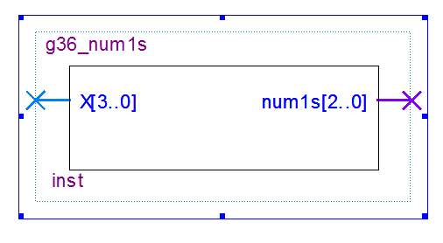

**Gate level schematic of the “g36_num1s” circuit**

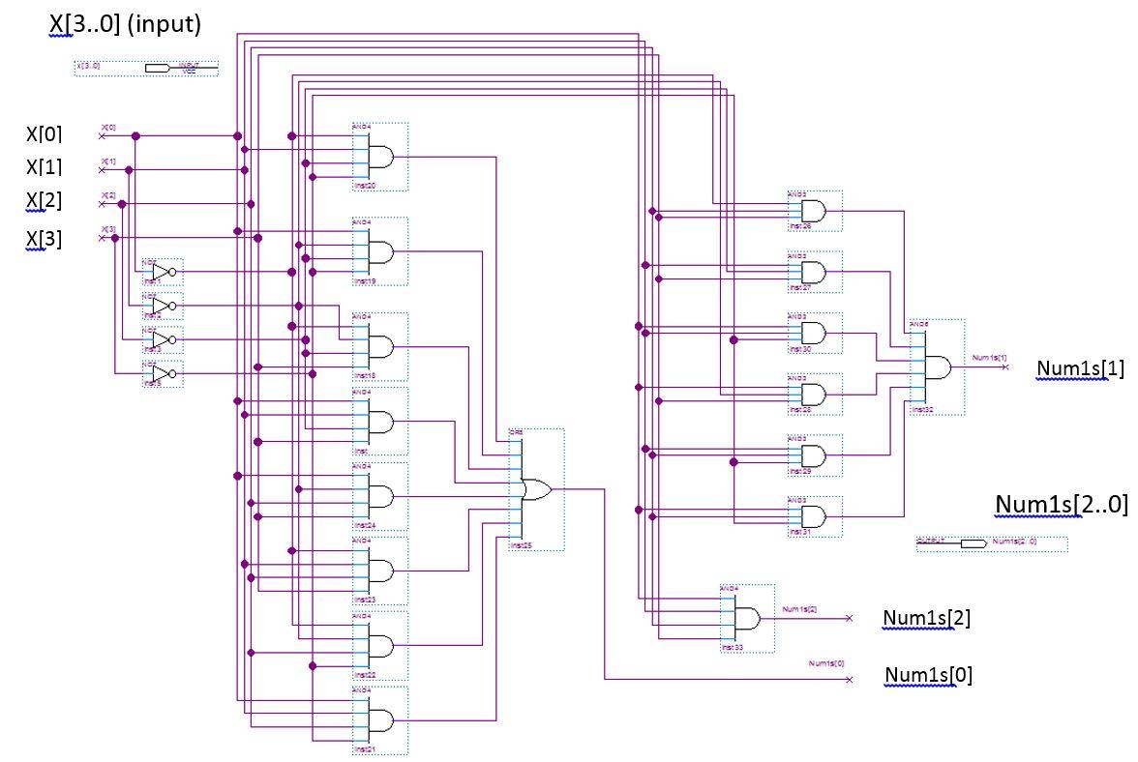

**Description of testing**   
  
In order to test the function, we created a test bench. The test bench changes the value of X every 10 ns with a for loop, such that every possible combination of the 4-bit array X is evaluated during a 10 ns interval. Given that there are 16 different possible values of X, the test lasts 160 ns. The test results are illustrated in the “Wave” tab of the Modelsim software, where values of both X and Num1s are shown (the value of Num1s are shown in decimal). Since there are only 16 possibilities, it is reasonable to visually verify that the value of Num1s does indeed correspond to the number of “1”s in X. This is what we did, and our circuit functions as expected.

